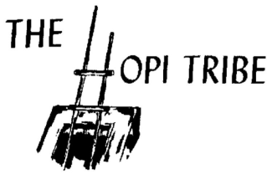
Official Newspaper of the Hopi Tribe
P.O. Box 123
Kykotsmovi, AZ 86039

LATEST NEWS – Impacts of Federal Shutdown of Tribal Programs/Services
October 2, 2013

According to Hopi Chairman LeRoy Shingoitewa, the shutdown of the Federal Government will have minimal impacts on Hopi Tribal operations. Hopi tribal programs receiving federal funding through grants and contracts will not be impacted immediately.
In a memo released via email to all tribal employees on Oct. 1, 2013, Hopi Tribe Executive Director Donovan Gomez said “although the situation Congress has created is serious and will cause harm to many tribes, all Hopi Tribal federal grant and contract programs will continue to provide services by relying on carryover funding from BIA and IHS as well as previously appropriated Tribal funds.”
BIE Hopi Agency schools will still be in operation as well as the BIE line office and IHS services will remain fully functional. Hopi BIA Law Enforcement, considered a critical service, will also remain fully functional.
Chairman Shingoitewa said, “Over time, the lack of Federal funding for certain programs and departments of the Tribe will be impacted, and the Council is considering action to temporarily address and alleviate any negative short-term impacts that the Federal government “shutdown” may have on the Tribe and it’s programs and employees. We will continue to monitor the situation and will periodically issue updates.”

