Hopi Behavioral Health Services I'm for Life Program is coordinating run/walk events, zoom presentation, and activities throughout the month of September to bring awareness and education to our Hopi/Tewa people regarding Suicide Prevention.
SEPTEMBER 2021

EVERYONE HAS A ROLE IN SUICIDE PREVENTION!
TAKE THE CHALLENGE TO EDUCATE YOURSELF ON SUICIDE PREVENTION

If you would like to send pictures of the activities you implemented please send to Chardy@hopi.nsn.us or BScott@hopi.nsn.us

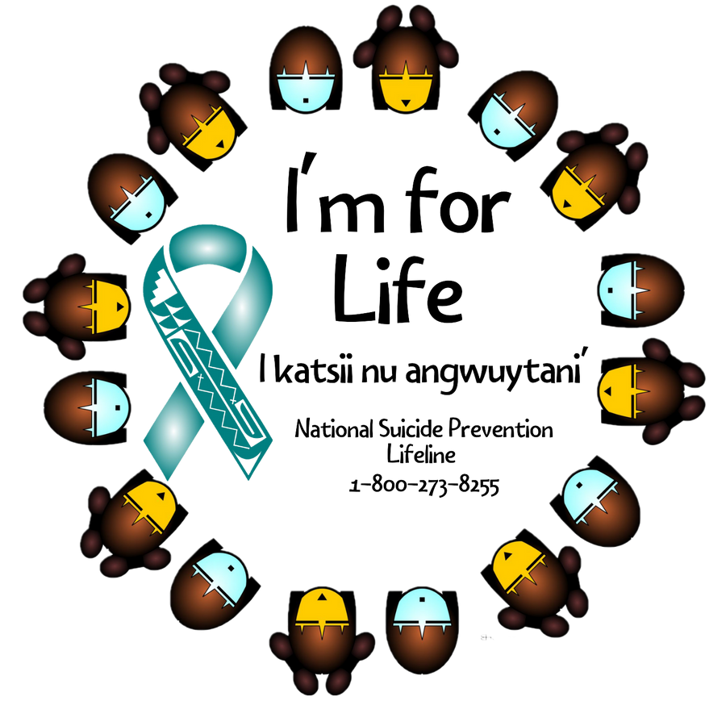
NATIONAL SUICIDE PREVENTION MONTH

S U N | M O N | T U E | W E D | T H U | F R I | S A T
 |  |  | 1  I'm for Life Run/Walk Moenkopi Comm. Center 6:00 PM  EDUCATE YOURSELF ON SUICIDE PREVENTION! | 2  Self Care & Resilience Presentation By Joe Baca  9:00am-10:00am | 3  Thank someone for the happiness they have brought into your life | 4  Family Movie Night
5  You are important, Your feelings matter, Your story matters, Your life matters! | 6  Reflect on what makes you special (letter to self) | 7  I'm for Life Run/Walk Peace Academic Center 6:00 PM | 8  2021 Indigenous Youth Suicide Prevention Conerence Sponsored by Native American for  Community Actions (NACA) | 9  2021 Indigenous Youth Suicide Prevention Conerence Sponsored by Native American for  Community Actions (NACA) | 1 0  2021 Indigenous Youth Suicide Prevention Conerence Sponsored by Native American for  Community Actions (NACA) | 1 1  Once you choose hope anything's possible!
1 2  You are more precious to this world than you'll ever know! | 1 3  Andrea's presentation | 1 4  Lexis Presentation | 1 5  Make dinner together as a family | 1 6  Perform a random kind of kindness | 1 7  Do something creative with your family | 1 8  Trust yourself!  You've survived a lot, and you'll survive whatever is coming!
1 9  Family Dinner | 2 0  Self Care & Resilience Presentation By  Joe Baca 9:00am-10:00am | 2 1  Family walk/run | 2 2  Read a book to your child/neice/nephew/ grandchild | 2 3  Safe Talk Presentation By Aeon & Charmayne First Mesa Youth Center @1:00pm | 2 4  Call a family or friend you haven't spoke to in awhile. | 2 5  Your time can change a life!
2 6  Stay Positive!  Better days are on their way! | 2 7  Lexi presentation | 2 8  Make a dessert with your family | 2 9  burn candle or release balloon with message | 3 0  Wear teal shirt day
For any questions please call (928) 675-8056 or email Bscott@hopi.nsn.us/Chardy@hopi.nsn.us

