September
2021  “Encouraging a life of sobriety through spiritual & cultural resiliency” |  | 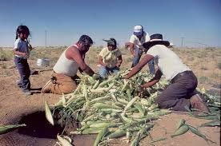
 |  | NASANMUYAW
Sunday | Monday | Tuesday | Wednesday | Thursday | Friday | Saturday
 |  |  | 1 | 2 | 3 | 4
 |  | August 31  International Overdose Awareness Day | I’m For Life Fun Run Moencopi @ 6PM  NACA: SafeTALK training 1:30 -5pm (Flagstaff) | 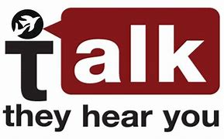 www.samhsa.gov | NATIONAL SUICIDE PREVENTION LIFELINE 800-273-8255 | Learn the FACTS!  Teens.drugabuse  .gov
5 | 6 | 7 | 8 | 9 | 10 | 11
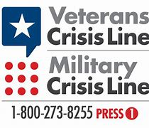 | LABOR DAY HOLIDAY | I’M FOR LIFE FUN RUN & WALK Peace Academy @ 6pm | INDIGENOUS YOUTH SUICIDE PREVENTION | nacainc.org  Fetal Alcohol Spectrum (FAS) Disorder Day | --------------------l Suicide Prevention Day “Wear Yellow” 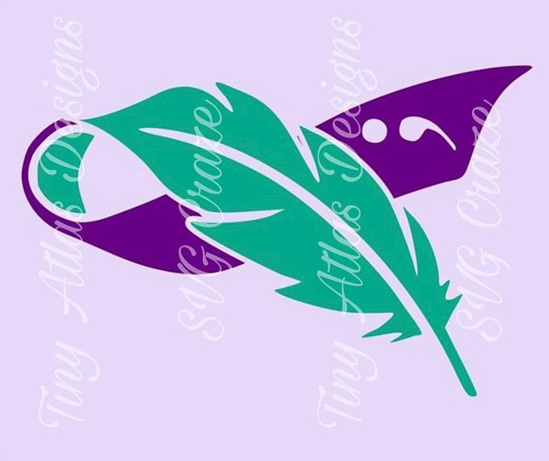 | 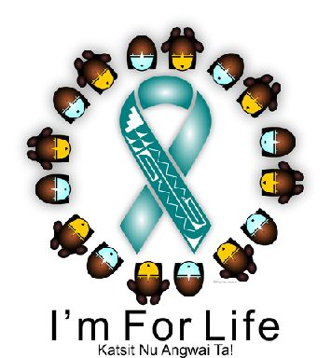
12 | 13 | 14 | 15 | 16 | 17 | 18
“Talk Early, Talk Often, Get Others involved” www.underagedrinking @samhsa.gov | Rock your RED Shoes - FAS Outreach @ Polacca Circle M 10:00 – 1:00 | Rock your RED Shoes - FAS Outreach @ Village Store 10:00 – 1:00 | 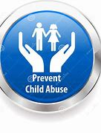 | NICWA: Working with Substance Abusing Families online: (nicwa.org)  8th Annual Tribal Summit Twin Arrows Casino (Eventbrite.com) |  | Heads Up for Students (scholastic.com)
19 | 20 | 21 | 22 | 23 | 24 | 25
We’re ALL in this TOGETHER www.nimh.nih.gov | Loving, nurturing, & stable home environments | STAY HAPPY!  STAY HEALTHY!  STAY DRUG FREE! | Rock your RED Shoes - FAS Outreach @ UVM Moenkopi 10:00 – 1:00 | SAY NO TO DRUGS!!  “Not TODAY, Not TOMORROW, Not EVER” | BEHAVIORAL HEALTH CRISIS HOTLINE  877-756-4090 | 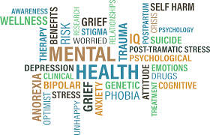
26 | 27 | 28 | 29 | 30
24/7 online chat  veteranscrisisline .net | 4th Annual AZ Drug Summit (online) | Positive Indian Parenting  8:00 – 4pm (FMYC) | ------------------l www.samhsa.gov | 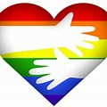

SOBRIETY & RECOVERY MONTH | 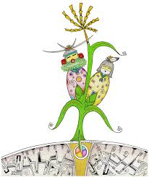 | Fetal Alcohol Spectrum Disorder is Preventable |  | Don’t let a bad day make you feel like you have a bad life

