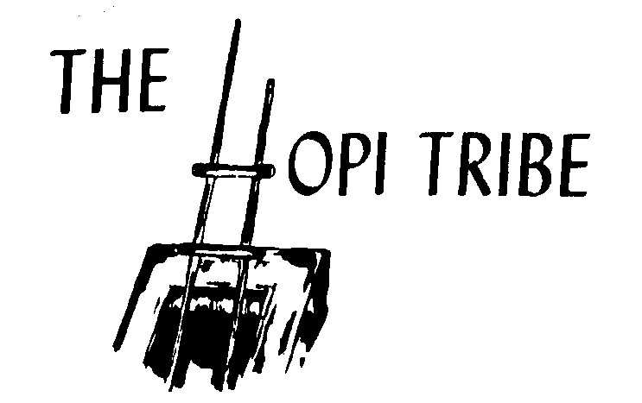
Program Use: Only:

2021-2022 Hopi Tribe Hunting & Trapping
Bobcat and Mountain Lion Permit Application

LAST NAME |  | FIRST NAME |  |  |  |  |  | M.I. |  | SEX |  | DATE OF BIRTH
CENSUS NUMBER | SSN# | HEIGHT | WEIGHT |  |  | EYE COLOR | HAIR COLOR |  |  |  |  |  | CONTACT NUMBER
 |  |  |  |  |  |  |  |  |  |  |  |  | ( )
MAILING ADDRESS |  | TYPE OF PERMIT APPLYING FOR:  (Check all boxes that may apply and enclose full amount of payment)
 |  | Tribal Member |  |  |  | Hunting and Trapping Permit |  |  | Mountain Lion Permit
 |  | Non-Tribal Member |  |  |  | Bobcat Permit |  |  | Contest Permit
Email Address |  |  |  |  |  | Bobcat Permit Tag |  |  | Trap Registration No. Permit
 |  |  |  |  |  | Number of Bobcats (Limit of 10 Per Day)
VACCINATION |  | YES | NO |  | TYPE: |  |  |  |  |  | DATE(S) OF VACCINATION:

A separate application and permit fee for each species is required.
Make Check or Money Order Payable to: The Hopi Tribe

Mail to:

Hopi Wildlife & Ecosystem Management Program
Attn: 2021 Hopi Hunt
PO BOX 123
Kykotsmovi, AZ
86039

