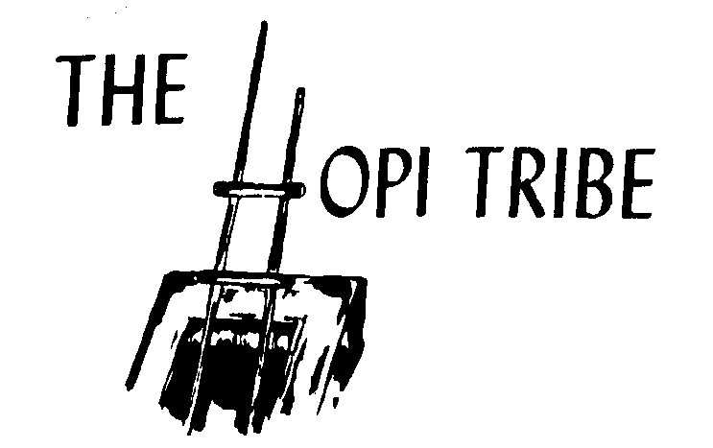
Program Use: Only:

2021 Hopi Tribe Deer and Elk
Hunting Permit Application

HUNT CHOICES (Circle One)  DEER ELK | 1ST CHOICE |  |  | 2ND CHOICE |  |  | 3RD CHOICE |  | 4TH CHOICE | SOCIAL SECURITY NUMBER
CENSUS NUMBER | LAST NAME |  |  |  |  |  |  |  |  | FIRST NAME |  | M.I.
DATE OF BIRTH | HEIGHT |  | WEIGHT |  |  | COLOR EYES |  | COLOR HAIR |  | SEX | CONTACT NUMBER
 |  |  |  |  |  |  |  |  |  |  | ( )
MAILING ADDRESS |  |  |  |  |  |  |  |  |  | EMAIL ADDRESS  (Optional. Used to keep hunters informed.)
VACCINATION | YES | NO |  |  | TYPE: |  |  |  |  | DATE(S) OF VACCINATION:

A separate application and permit fee for each species is required.
Make Check or Money Order Payable to: The Hopi Tribe

Mail to:

Hopi Wildlife & Ecosystem Management Program
Attn: 2021 Hopi Hunt
PO BOX 123
Kykotsmovi, AZ
86039

